Brownsville Independent School District

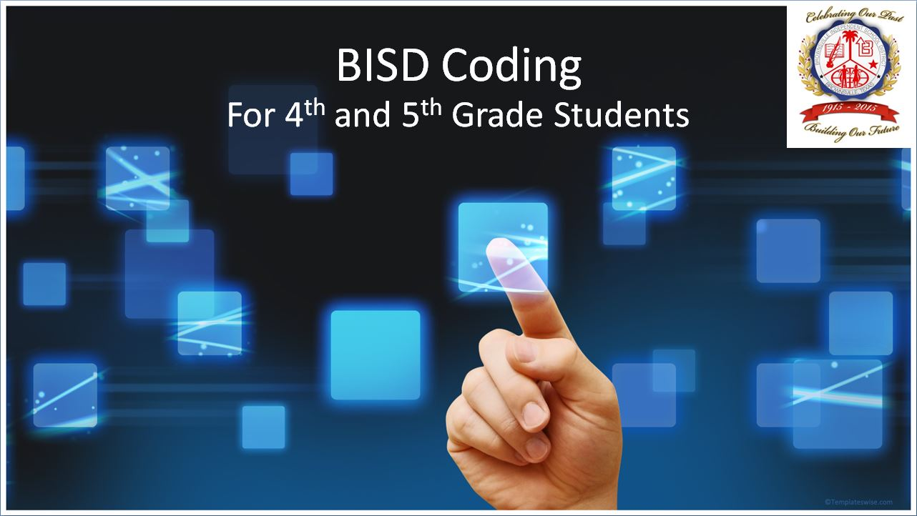

2017-2018

Coding Handbook

BISD does not discriminate on the basis of race, color, national origin, sex, religion, age, disability or genetic information in employment or provision of services, programs or activities.
BISD no discrimina a base de raza, color, origen nacional, sexo, religión, edad, discapacidad o información genética en el empleo o en la provisión de servicios, programas o actividades.

Brownsville Independent School District
Board of Trustees

Cesar Lopez
President

Carlos A. Elizondo

Vice-President

Joe A. Rodriguez
Secretary

Laura Perez-Reyes
Assistant Secretary

Dr. Sylvia P. Atkinson
Member

Minerva M. Peña
Member

Philip T. Cowen
Member

Dr. Esperanza Zendejas
Superintendent of Schools

Brownsville Independent School District

Table of Contents

I. Coding Organizational Chart………………………………..…………….. 4

II. Standard Operating Procedures……………………………………..…… 5
- Description……………………………………………………………….. 5
- Coding Sponsor Qualifications ……………………………………… 5
- Coding Sponsor Staff Development…………………………………. 5
- Coding Sponsor Responsibilities…………………………………….. 5
E. Eligibility…………………………………………………………………… 6
1. Participation………………………………………………………… 6
2. Recruiting…………………………………………………………… 6

F. Coding Budget……………………………………………………………. 6
1. Stipends………………………………………………………………. 6

G. Coding Attendance………………………………………………………. 6

III. Coding Challenges……..……………………………………………….……. 7

IV. Coding and Education Technology Summit ………………………….. 7

V. References…………………………………………………………………….. 8

Coding Organizational Chart

School Board

Dr. Esperanza Zendejas
Superintendent of Schools

Berta Peña
Assistant Superintendent
Curriculum & Instruction

Carlos Olvera
Curriculum & Instruction

David Mitchell / Lorena Martinez
Technology Services Department

Campus Principals

Coding Sponsors

Coding Students

Standard Operating Procedures
Elementary Level

Description

The Brownsville Independent School District will provide Coding Instruction to BISD 4th and 5th grade students. Coding is one of the largest growing occupations in the world with a high demand in the workforce.
Tufts (2014) states teaching children how to code will provide a lifetime of benefits including:
1. improve traits needed in the future,
2. improve problem-solving skills,
3. motivate students to learn,
4. improve technology skills,
5. improve memory skills,
6. learning Coding as a universal language and
7. prepare students to be the next generation of programmers.

Coding Sponsor Qualifications

Coding sponsors are certified teachers.

Coding Sponsor Staff Development

For the 2017-2018 school year, RETURNING experienced coding sponsors will receive ½ day refresher training. New Coding sponsors will receive a full day Coding Instruction Training. Coding sponsors are trained in the use of the Office 365 ONEDRIVE Platform, MIT SCRATCH, and CODE.ORG.

Coding Sponsor Responsibilities

The Coding Sponsor will:
- provide coding instruction to participating 4th and 5th grade students
- sponsor Club Code at their campus.
- submit the Six Coding Challenges (due at the end of each six weeks)
- promote the Education Technology and Coding Summit scheduled for May 2018
- coordinate the campus participation in the HOUR of CODE (December 4th – 10th, 2017)
- Work with the Coding Sponsor Folder to access Coding information, updates, newsletter, upload Coding photos, and more.

Student Eligibility

Participation:

- Elementary participation is open to students in 4th and 5th grades.

- The campus Coding Clubs will be composed of 4th and 5th graders.

Recruiting: Coding Club sponsors shall recruit throughout the school year to maintain a Coding Club with NO less than 10 students (per grade level)

Coding Budget

Stipends: Each coding sponsor will receive a $2000 stipend*. There will be one Coding Sponsor per campus. The campus principal will submit the name for the Coding Sponsor by August 11, 2017 via ONEDRIVE Survey form. Only Certified BISD teachers will be able to serve as sponsors. The BISD Stipend Form will be submitted by the C& I Department, listing the 37 Coding Sponsors.

*as per the BISD board compensation plan

Coding Attendance

Students will sign in digitally as they sit at their Coding computer by accessing the
Elementary Coding Student Sign in Form

Coding Practice Schedule:
All coding sponsors must hold practice a minimum of 3 hours per week from September 2017 to May 2018. Coding Sponsor will ensure that they have access to a campus computer lab throughout the year to for Coding Instruction. Campus coding sponsors will submit their coding schedules through a ONE DRIVE FILE. Elementary Coding Campus Schedules

Coding Challenges

- The coding challenges will be posted on the ONEDRIVE for teachers to download and have their students work on.

- The coding sponsors will coordinate their campus coding challenges. Coding sponsors may contact technology services for support. Each campus will submit their top Coding Challenge product for 4th grade and for 5th grade (Total 2 submissions per campus).

- Campus coding club members will submit their Coding program by copying the MIT SCRATCH LINK to the ONEDRIVE File provided by C & I.

- First, second and third places will be awarded for 4th grade and also for 5th grade. Results will be shared through the Coding Program Newsletters.

Coding and Technology Education Summit

The Coding and Technology Education Summit will be the culminating event for the 2017-2018 Coding Program.

- Students will showcase their projects and challenges at their own booth.
- Coding sponsors will coordinate with the district Coding sponsor to ensure that all campuses are represented.
- The CTE department will work with CTE teachers and high school groups to showcase their work to the 4th and 5th grade students.
- The community will have an opportunity to view projects and learn about education technology from our BISD students.

Transportation will be provided to the Coding and Technology Education Summit.

Hour of Code

BISD elementary campuses will be participating in the Hour of Code scheduled to take place from December 4th – 10th, 2017.

References

Tufts, P. (2014). 7 Lifetime Benefits of Teaching Coding Games for Kids to Your Kids. Retrieved August 1, 2016, from http://learntocode.biz/7-lifetime-benefits-of-teaching-coding-games-for-kids-to-your-kids/

